DTEK2081 Algorithmic Foundations of Robotic and AI Systems
Assignment 1 (LAB 1)
Group 18
Mahmmud Qatmh & Lassi Ahlstrand

Task 1:
For Task 1, we created a ROS2 Python package named pose_line containing two nodes: a publisher (publisher_pose.py) that simulates a robot moving in a straight line by publishing geometry_msgs/PoseStamped messages at 2 Hz, and a subscriber (subscriber_pose.py) that listens to the robot_pose topic and prints the x and y positions. The package is structured with all Python modules inside pose_line/pose_line/ and includes a proper __init__.py and setup.py with console entry points. After building the package with colcon build and sourcing the workspace, we ran the publisher and subscriber nodes, verified the existence of the robot_pose topic, echoed its messages, checked the message frequency using ros2 topic hz /robot_pose, and confirmed the number of publishers and subscribers with ros2 topic info /robot_pose. This setup fully demonstrates ROS2 publisher/subscriber communication with PoseStamped messages in a straight-line movement scenario.
Output:

1. publisher and subscriber launch
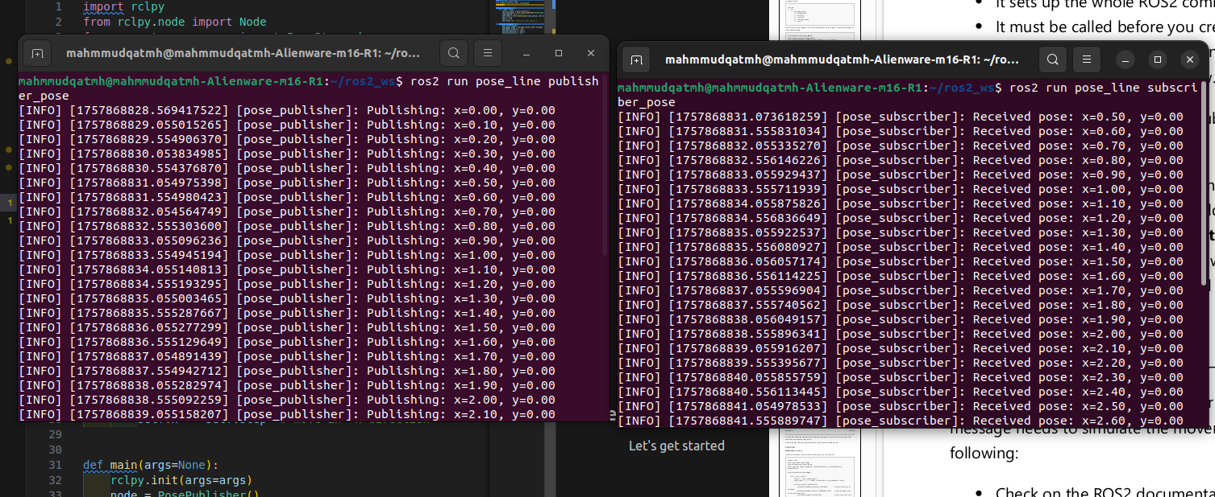

verify on terminal

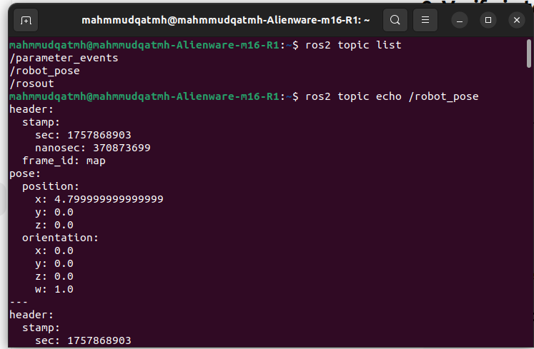

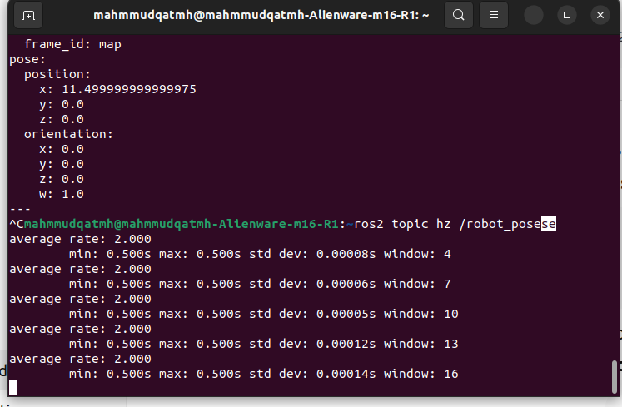

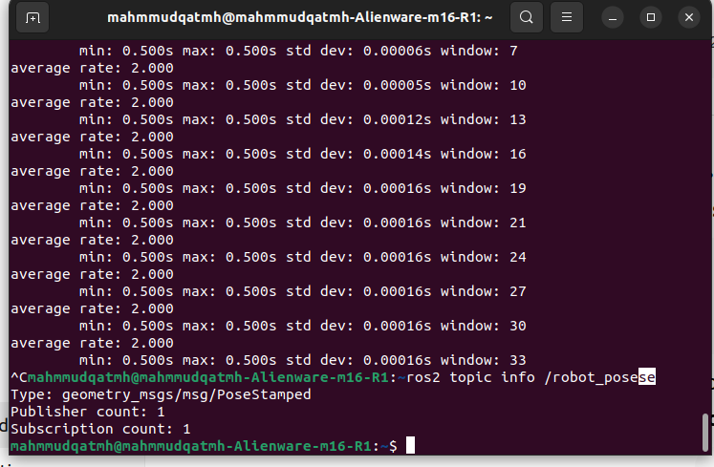

Optional:
1. Quality of Service for

For essential information, such as safety information, or control commands, which are never to get lost, you would generally use:

Reliability: RELIABLE → assured message transmission (with retries if needed).

Long-term storage: VOLATILE → usually plentiful, as old messages expire very quickly.

History: KEEP_LAST dengan antrian sangat kecil (contohnya, 10) → hanya menyimpan pesan terkini.

Deadline: Set based on how frequently you anticipate messages; it is used to identify skipped updates.

Examples: Safety stop commands or robot critical status reports.

2. QoS for Live Data

For raw data, e.g., sensor streams (cameras, LiDAR, odometry

Reliability: BEST_EFFORT → occasional loss is tolerated in favor of ensuring real-time performance.

durability: VOLATILE→ no need for previous data, only latest.

History: KEEP_LAST or KEEP_ALL based upon bandwidth and buffer size.

Deadline: Set in order to have the subscriber anticipate new data at a certain rate.

Example: Sensor values at high rate, where lost or lagging messages are allowable.

3. When to Use Transient Local

TRANSIENT_LOCAL durability is applicable when subscribers who join late require old messages.

This is fair for necessary messages to complete a system or preserve state, although a subscriber may not have been active when originally posted.

Examples:

Configuration Parameters

Map data in navigation
=====================

Current localization position for robot

custom messaging
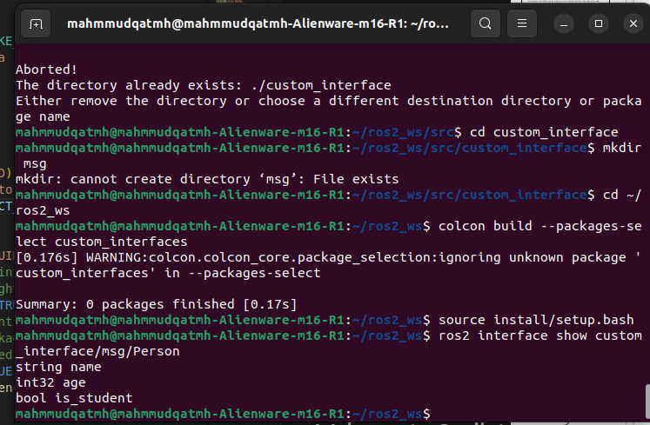

Task 2:
we created a ROS2 system using a custom message. First, we built the package person_msgs which defines the Person.msg message with fields string name, int32 age, and bool is_student; the files involved were person_msgs/msg/Person.msg, person_msgs/package.xml, and person_msgs/CMakeLists.txt. Next, we created a Python package person_node that depends on person_msgs and contains two nodes: the publisher (person_node/publisher_person.py) publishes a student’s name and age (between 10 and 18) on the person_info topic, while the subscriber (person_node/subscriber_person.py) listens to the topic and logs the received information. The Python package also includes person_node/__init__.py, setup.py (which declares person_msgs as a dependency), and resource/person_node. After building both packages with colcon build and sourcing the workspace, we ran the publisher and subscriber, and verified the topic existence, message content, frequency, and number of publishers/subscribers using ROS2 CLI commands. This setup demonstrates creating and using a custom ROS2 message in a Python publisher/subscriber system.

Output:
optional:
we already used the header that includes time stamp as per the picture of the terminal above.

Task 3:

In this task, a new package named distance_service was created to implement a custom service for calculating the distance between two 2D points. A new service interface Distance.srv was added in the custom_interface package, which takes two geometry_msgs/Point values (a and b) as input and returns three outputs: the computed distance (float64 distance), a success flag (bool success), and a descriptive message (string message). The package includes two Python nodes: distance_server.py, which acts as the service server by receiving the two points, computing the Euclidean distance using the formula √((x₁–x₂)² + (y₁–y₂)²), and returning the results; and distance_client.py, which sends two points as input parameters, calls the service, and logs the returned distance, success status, and message. This design ensures both successful calculation and error handling. The structure of the service interface can be confirmed in the terminal using the following command:

Output:

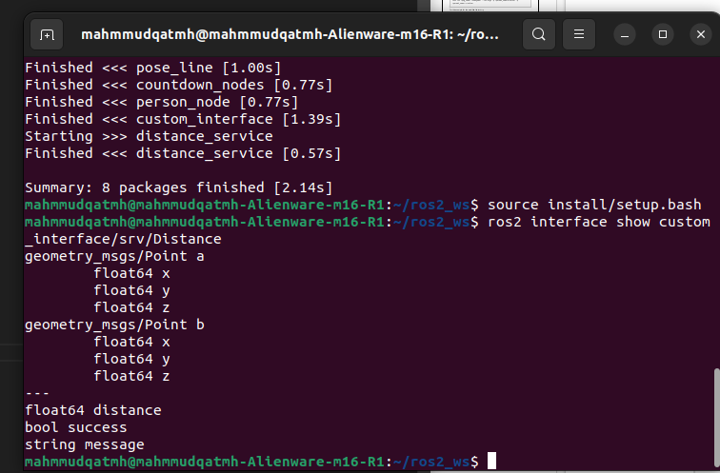

Task 4:
In this task, we extended the distance calculation service from Task 3 by introducing parameterization for the two input points and using a YAML file to pass these values at runtime. The service (distance_server.py) still computes the Euclidean distance between two points, but instead of hardcoding or manually passing the coordinates, the client (distance_client.py) now retrieves them as parameters. To make the setup reusable, we created a YAML file at distance_service/config/params.yaml, which defines the parameters a_x, a_y, b_x, and b_y for the client node. This way, we can easily launch the server and client while the client reads its input points directly from the YAML file, ensuring flexibility and clearer configuration management.

Output:

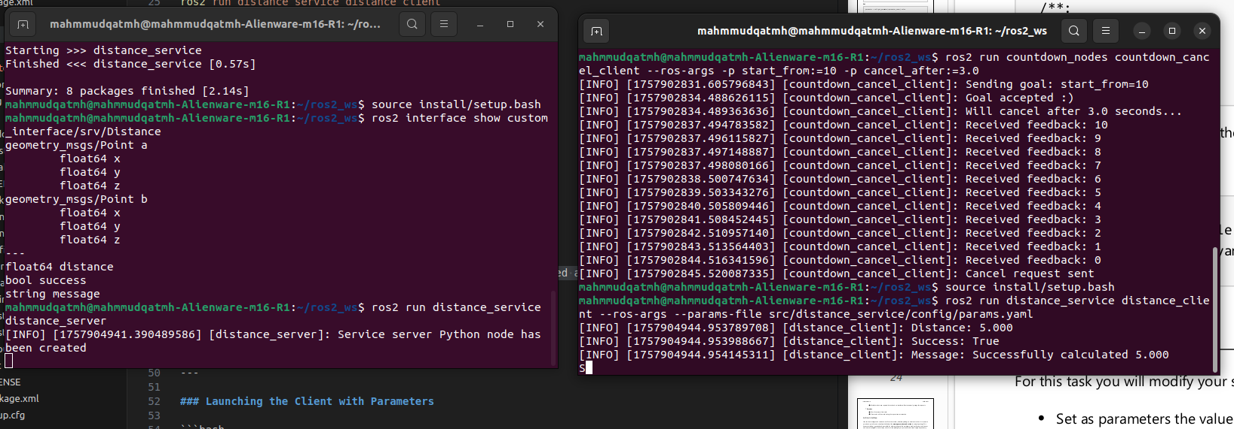

Task 5:
we implemented an Action Protocol in ROS 2 using Python to create a countdown system with cancellation support. First, we defined a new action file Countdown.action inside the custom_interface package, with the format:
“int32 start_from
---
string result_text
---
int32 current “

This allowed us to send a starting number, receive ongoing feedback as the countdown progresses, and return a final result. Then, we created a new package countdown_nodes containing multiple nodes: countdown_action_server.py (the server that performs the countdown and publishes feedback), countdown_client.py (a client that sends a goal and receives feedback until completion), and countdown_cancel_client.py (a second client that not only sends the goal but also cancels it after a specified time, using ROS 2 parameters for start_from and cancel_after). The setup.py and package.xml files were updated to include dependencies on rclpy and custom_interface. Finally, we verified the action structure with the command:
“ros2 interface show custom_interface/action/Countdown”

which confirmed the defined fields. Together, these files and steps allowed us to test normal countdown execution and cancellation behavior via the terminal.

Output:
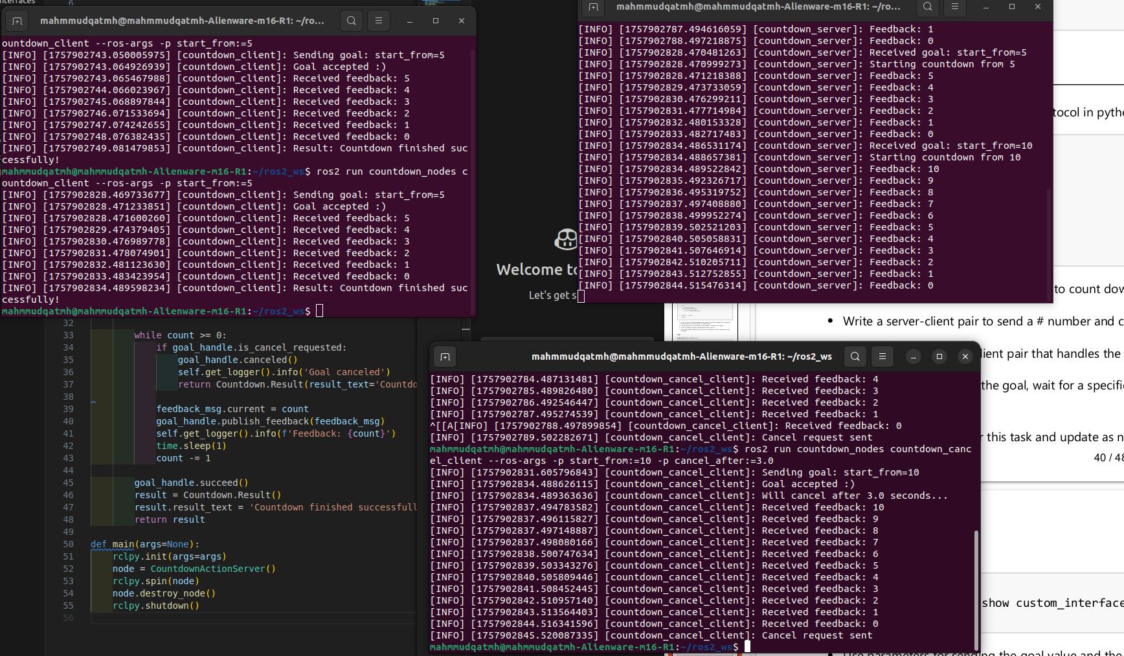
Task 6:
In this task, we created a new package called distance_bringup dedicated to launch files, and configured it to manage both the service server and client for the distance calculation. A launch file named params.launch.py was placed in distance_bringup/launch/, which starts the distance_server and distance_client nodes from the distance_service package. The client node is configured to load its parameters from a YAML file (params.yaml) located in the config directory of the bringup package, making it easy to adjust input points without modifying code. This setup ensures both nodes run together with proper configuration management, and the YAML file cleanly separates logic from runtime parameters.
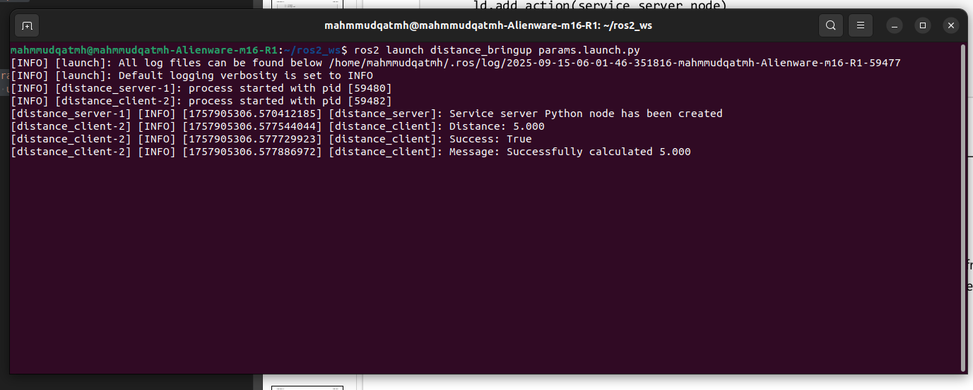
Output:

